2. Write a Prolog program that prints the message Hello Prolog to the console.
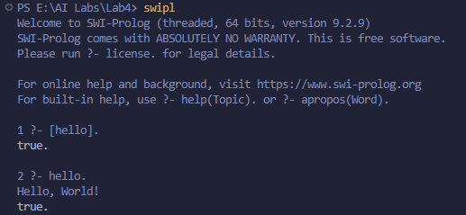
3. Write a Prolog Program to Represent Simple Relationships.
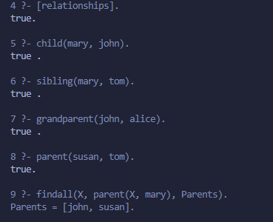
4. Write a Prolog program that determines friendship between two people based on common interests.
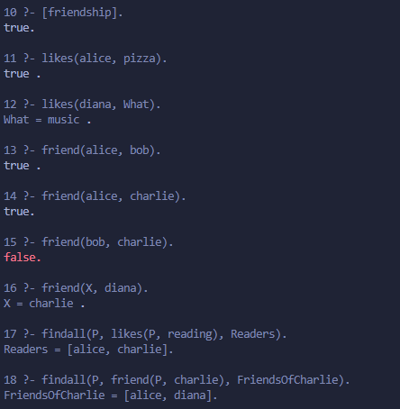
5. Create a Prolog program that models family relationships using facts and rules for parenthood, gender, and sibling relations.
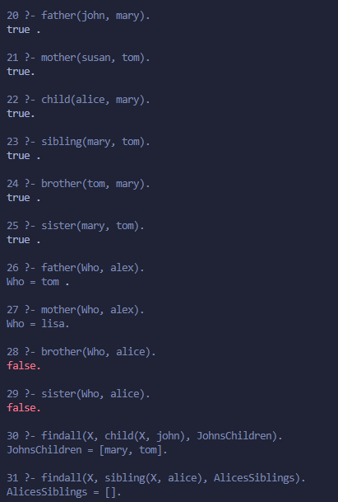
6. Use Prolog rules and a given fact to demonstrate that if all mammals are warm-blooded and all cats are mammals, then all cats are warm-blooded.
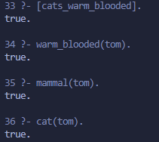
7. Write a program in Prolog for the following FOPL.
- All engineers are problem solvers.
- All software developers are engineers.
- All problem solvers are analytical thinkers.
- Everyone who drinks coffee is good at something.
- Alice is a software developer.
- Alice drinks coffee.
- To Prove: Alice is an analytical thinker and good at something.
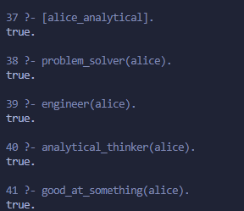

8. Use Definite Clause Grammars (DCG) in Prolog to parse simple English sentences consisting of a noun phrase and a verb phrase.
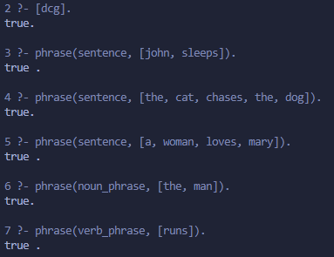
9. Create a Simple Medical Expert System Using Prolog.
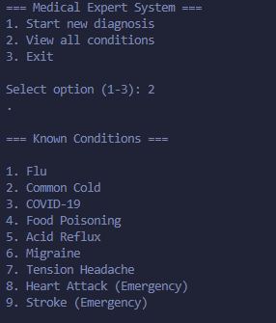
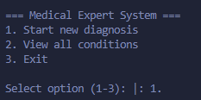
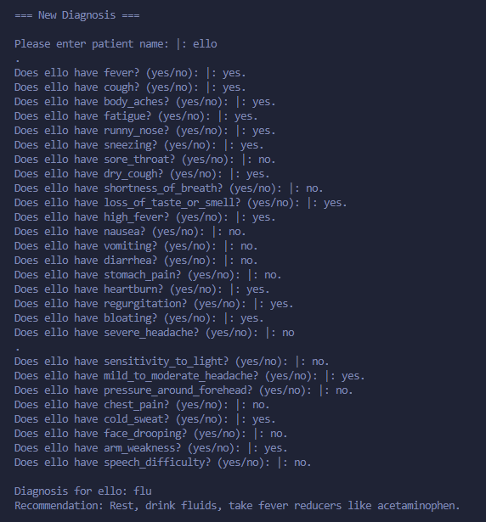
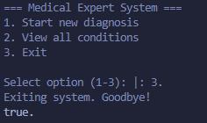
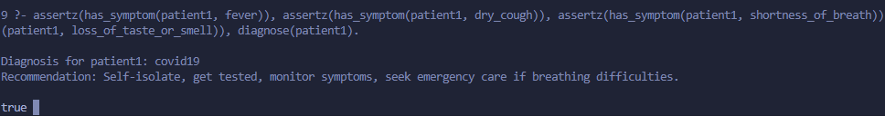
10. Write a Prolog program to solve the water jug puzzle: measure exactly 2 gallons using two jugs of capacities 4 and 3 gallons.

